Chapter 1

**Introduction**

**1.1 Introduction**

There is total 6 level (0-5) of autonomy for car. First five (0-4) is/was in production line and rest of is in theory. In each level the system evolves to make commuting faster, safer and hassle free. The concept of ‘Self Driving’ car is not a new buzz. It’s been here for a while. But still full autonomous car does not pass the full attorney from the lawsuit. It is restricted by some chech and region. This drawback has some pretty good reasons. Cause commuting evolves real human life. Putting human life in steak is not a viable trade to technology. The main reason is, the existing autonomous is not responsive, transparent and secured enough.   
Traffic Symphony is a system to solve these issues by putting together some basic technology. Making the system responsive by using cloud infrastructure, the security and transparency is handled by a hyper ledger which is a domain of block chain technology.

**1.2 Objective**

The approach is to implement [communication networks](https://en.wikipedia.org/wiki/Communication_networks) both in the immediate vicinity (for [collision avoidance](https://en.wikipedia.org/wiki/Collision_avoidance_system)) and farther away (for congestion management). Such outside influences in the decision process reduce an individual vehicle's autonomy, while still not requiring human intervention. The 5th level of autonomous car is still not in production line. So the literal implementation of 6th level is inconceivable. The main objective of the project is building a virtual environment, which demonstrates the infrastructure of 6th level autonomous car.

**1.3 Motivation**

The main motive of the infrastructure is to diverge the three main problem of existing autonomous system for which the whole system is facing lawsuit to be viable in production line. Making commuting faster, Safer, Secure.

**1.4 Scope of The Project**

Level 6th autonomous infrastructure opens a whole new window for commuting. Offering the best environment to the automotive industry. At this level, the vehicle needs no human control at all. It doesn’t need to have pedals, or a steering wheel, or even a human onboard.

The car is fully automated and can do all driving tasks on any road, under any conditions, whether there’s a human on board or not. The system is fully controlled by AI, capable of performing any kind of task which a human can do.

The simulation “Traffic Symphony” is a environment to test out the infrastructure just like in real life.

**1.5 Organization of The Project:**

The project is divided into the two parts. One is “The level 6th infrastructure” which describes the theoretical infrastructure and the technological alignment for the literal implementation.   
The other part “The traffic symphony” is a simulated environment of the infrastructure. It can be said that this part is “The Narrator” of the project.   
Therefore, the organization of the project is arranged in following way:

* The 1st chapter “Introduction” contains the information about project motivation, the objective and the scope of the project.
* The 2nd chapter “About the Infrastructure” is a dedicated chapter. Explaining the theoretical arrangement of the infrastructure.   
  The rest of the chapters are about “The Traffic Symphony” which is the actual simulation.
* The 3rd chapter “Literature Review” contains the information about “The Traffic symphony” and its feature. Related technical terminology is demonstrated here.
* The 4th chapter “System Analysis” contains the information about the system specification, requirement analysis, and feasibility study.
* The 5th chapter “Proposed System Design” contains the information about the system design of the proposed simulation.
* The 6th chapter “System Development” contains the information about platform overview & implementation process.
* The 7th chapter “System Testing” contains the information about testing of the proposed theory in the simulation, testing the system platform and debugging.
* The 8th chapter “Comparison” contains a comparison between existing infrastructures and proposed system.
* The 9th chapter “Conclusion & Future Work” Contains a short conclusion of the system an future scope.

**1.6 Summary**

In this chapter the introduction about the system “The Traffic Symphony” and the level 6th autonomous infrastructure is demonstrated. It also includes the motivation, scope and organization of the system.

Chapter 2 **Literature Review**

**2.1 Introduction to The Autonomy**

The autonomous commuting infrastructure is not only just a single autonomous system. It contains a number of fragmented but individual working segments, from the Car engine to the Cloud based AI.

**2.1.1 The Self Driving Vehicle**

A self-driving car, also known as an autonomous vehicle (AV), connected and autonomous vehicle (CAV), driverless car, robo-car, or robotic car, is a [vehicle](https://en.wikipedia.org/wiki/Vehicular_automation) that is capable of sensing its environment and moving safely with little or no [human input](https://en.wikipedia.org/wiki/User_interface).

Self-driving cars combine a variety of sensors to perceive their surroundings, such as [radar](https://en.wikipedia.org/wiki/Radar), [lidar](https://en.wikipedia.org/wiki/Lidar), [sonar](https://en.wikipedia.org/wiki/Sonar), [GPS](https://en.wikipedia.org/wiki/GPS), [odometry](https://en.wikipedia.org/wiki/Odometry) and [inertial measurement units](https://en.wikipedia.org/wiki/Inertial_measurement_unit). Advanced [control systems](https://en.wikipedia.org/wiki/Control_system) interpret [sensory information](https://en.wikipedia.org/wiki/Sensory_information) to identify appropriate navigation paths, as well as obstacles and relevant [signage](https://en.wikipedia.org/wiki/Road_signs).

**2.1.2 Different Level of Autonomous Vehicle**

***Level 0 (No Automation)***

Most vehicles are at this level today. The human driver controls all aspects of driving – from steering to operating the pedals, monitoring surroundings, navigating, and determining when to signal or manoeuvre. The car may have some automated warning tones and automated emergency braking.

***Level 1 (Driver Assistance)***

Vehicles with this level of autonomy, in some driving modes, can handle steering or throttle and braking – but never both. However, the driver must be ready to take over those functions if called upon by the vehicle. Level 1 cars also have some systems that use information about the driving environment, but the human driver monitors the driving environment. Level 1 autonomous systems have been available on production cars for several years, and features such as self parking and lane assistance fall into this bracket.

***Level 2 (Partial Assistance)***

At Level 2, vehicles can handle the steering and throttle and braking in some driving modes. The driver has to be alert at all times and ready to take over the control of the vehicle, and is still responsible for monitoring the surroundings, traffic and road conditions.

An example of Level 2 autonomy is Tesla’s Autopilot. This is a suite of driver assistance technologies including Traffic Aware Cruise Control and Auto steer with lane change, which enables automatic steering on undivided roads but with speed restrictions.

***Level 3 (Conditional Assistance)***

With Level 3 autonomy, the vehicle can monitor its surroundings, change lanes, and can control the steering, throttle and braking in certain situations, such as on motorways. However, the driver must be ready to take back control of the vehicle when required.  
The new Audi A8 is the first production car to have Level 3 autonomy. At the push of a button, the A8′s AI Traffic Jam Pilot manages starting, steering, throttle and braking in slow-moving traffic at up to 60km/h on major roads where a physical barrier separates the two carriageways. When the system reaches its limits the driver is alerted to take over the driving. Because of local laws and regulations regarding autonomous diving, Audi has said it will use a step-by-step approach to the introduction of the traffic jam pilot in its production models.

***Level 4 (High Automation)***

Level 4 automated cars can drive themselves with a human driver onboard. The car takes control of the starting, steering throttle and braking as well as monitoring its surroundings in a wide range of environments and handling the parking duties. When the conditions are right, the driver can switch the car to autonomous mode then sit back, relax and take their eyes off the road. When the vehicle encounters something that it cannot read or handle it will request the assistance of the driver.However, even if the driver does not intervene and something goes wrong, the car will continue to maneuver autonomously. These cars are truly self-driving and the Google/Waymo self-driving vehicle has been operating at the level of autonomy for a few years.

***Level 5 (Full Automation)***

At this level, the vehicle needs no human control at all. It doesn’t need to have pedals, or a steering wheel, or even a human on board. The car is fully automated and can do all driving tasks on any road, under any conditions, whether there’s a human on board or not.  
Several current concept cars are Level 5 autonomous vehicles – including the Volkswagen Group SeDriC (SElf-DRIving Car), above, and the Audi AIcon concept.

**2.2 SELF-DRIVING Cars LAWSUIT**

Self-driving cars are revolutionizing the concept of driving and car ownership, turning

“drivers” into passive passengers. Though experts claim that this new technology is safer than the average human driver, self-driving cars can still crash.

We are still a few years away from mass production, but autonomous driving technology, specifically Tesla’s Model S, has allegedly already caused two fatalities. Tesla now faces a [class action lawsuit](https://www.classaction.com/lawsuits/) for its autopilot program, which plaintiffs argue was sold without standard safety features.

But, Tesla isn’t the only manufacturer who has put unsafe [self-driving vehicles](https://www.classaction.com/self-driving-cars/) on the roads: Uber, Google, and General Motors vehicles have also crashed, further weakening manufacturers’ claims that autonomous vehicles are safer than human drivers.

According to the [Washington, DC](https://en.wikipedia.org/wiki/Washington,_DC)'s [district code](https://en.wikipedia.org/wiki/Code_of_the_District_of_Columbia): "Autonomous vehicle" means a vehicle capable of navigating District roadways and interpreting traffic-control devices without a driver actively operating any of the vehicle's control systems. The term "autonomous vehicle" excludes a motor vehicle enabled with active safety systems or driver- assistance systems, including systems to provide electronic blind-spot assistance, crash avoidance, emergency braking, parking assistance, adaptive cruise control, lane-keep assistance, lane-departure warning, or traffic-jam and queuing assistance, unless the system alone or in combination with other systems enables the vehicle on which the technology is installed to drive without active control or monitoring by a human operator.

In the same district code, it is considered that:

An autonomous vehicle may operate on a public roadway; provided that the vehicle:

* Has a manual override feature that allows a driver to assume control of the autonomous vehicle at any time;
* Has a driver seated in the control seat of the vehicle while in operation who is prepared to take control of the autonomous vehicle at any moment; and
* Is capable of operating in compliance with the District's applicable traffic laws and motor vehicle laws and traffic control devices.

**2.3 The Proposed Infrastructure**

The level – 6 Infrastructure is consisting of AI, Cloud and Block Chain technology.

**2.3.1 The Cloud and The Local AI**

The Proposed infrastructure uses and puts the cloud automation in test. Each car continuously interprets with the local AI (Car’s Agent) updating its current position and sate of the vehicle, from the fuel meter to the surrounding data from the sensors. The local AI process and chose which data should be uploaded.

**2.3.2 The BlockChain and The Hyperledger**

Hyperledger (or the Hyperledger project) is an [umbrella project](https://en.wikipedia.org/wiki/Umbrella_organization) of [open source](https://en.wikipedia.org/wiki/Open-source_software) [blockchains](https://en.wikipedia.org/wiki/Blockchain_(database)) and related tools, started in December 2015 by the [Linux Foundation](https://en.wikipedia.org/wiki/Linux_Foundation), and has received contributions from [IBM](https://en.wikipedia.org/wiki/IBM), [Intel](https://en.wikipedia.org/wiki/Intel) and [SAP Ariba](https://en.wikipedia.org/wiki/SAP_Ariba), to support the collaborative development of [blockchain](https://en.wikipedia.org/wiki/Blockchain)-based [distributed ledgers](https://en.wikipedia.org/wiki/Distributed_ledger). According to the IBM journal Hyperledger Fabric is a permissioned blockchain infrastructure, originally contributed by [IBM](https://en.wikipedia.org/wiki/IBM) and [Digital Asset](https://en.wikipedia.org/wiki/Digital_Asset_Holdings), providing a modular architecture with a delineation of roles between the nodes in the infrastructure, execution of [Smart Contracts](https://en.wikipedia.org/wiki/Smart_contract) (called "chaincode" in Fabric) and configurable consensus and membership services. A Fabric Network comprises "Peer nodes", which execute chaincode, access ledger data, endorse transactions and interface with applications. "Orderer nodes" which ensure the consistency of the blockchain and deliver the endorsed transactions to the peers of the network, and Membership Service Providers (MSPs), generally implemented as a Certificate Authority, managing [X.509](https://en.wikipedia.org/wiki/X.509) certificates which are used to authenticate member identity and roles. So here the main context is “What Gives!” . From the Hyperledger terminology “Hyperledger Fabric is a permissioned blockchain infrastructure-”. Once the data is uploaded by the local AI of an autonomous car, A digital signal is created. The signal is permitted by other car’s state. Every car works as a node and each phase is a digital signature which is validated by other nodes. Once the signal is validated it updates the ledger.

**2.3.4 The Remote or Server AI**

The server AI interprete with both the ledger and the car. Each state of the ledger is a new pattern for the server AI. It process the state and provide the necessary instruction to the local AI.

**2.4 The Proposed Lawsuit**

* Each car will have to pass a certain simulation test after being manufactured.
* The system should be monitored by the government not by any individual company.
* Every manufacturers should be agreed on a mutual agreement for connecting to the network.

**2.5 The Three Dimensional Preview**

Traffic Symphony is build dimensional to experience the most life like environment. The 3d model is created by complex geometric entities. Using simple, light yet powerful technology the model can be process faster. Not using the machine intensive technology was the great challenge and is a big advantage here. The dashboard provides fine control over both aurthographic and projection camera. The 3d object elements are responsive and tactile. Several real world traffic situations like deadlock, fire/ambulance emergency, traffic congestion can be created over the simulation. The simulation provides the full control over the situation and capable of interpreting with the outcome to see how the 3d model car behaves.

**2.6 Open and Web Based**

Considering the motive of making the simulation lighter and machine independent “The Traffic symphony” is rendered on a browser. The simulation is not machine intensive like other render application like Unreal Engine, Blender or even Unity3D. The system is open and consisting of a responsive dashboard which offers a number of functionality.

**2.7 The Ledger**

The Hyperledger, which defines the infrastructure as transparent and secured using the blockchain technology. The ledger is open yet only Re-writeable and manageable by the system’s states and conditions.

**2.8 The Remote AI**

The remote or server AI is created virtually here. This interprete with the ledger and the virtual 3d cars. It process the data from the ledger and virtual create patterns using basic graph algorithm like DFS/BFS to determine shortest and feasible path to the destination. There is some penalty for each collision and reward for each successful operation. The real world scenarios can be created to see how the model behaves. The system is going to refine mathematical boundaries continuously by observing the outcomes.

**2.9 The Properties of a Autonomous Vehicle**

Autonomous vehicles (AVs) use technology to partially or entirely replace the human driver in navigating a vehicle from an origin to a destination while avoiding road hazards and responding to traffic conditions. Given the broad spectrum of AVs, the National Highway Traffic Safety Administration (NHTSA) has developed a five-level classification scheme based on vehicle capabilities. The Society of Automotive Engineers (SAE) has developed a similar classification with six levels based on human intervention, separating Level 4 NHTSA into two levels

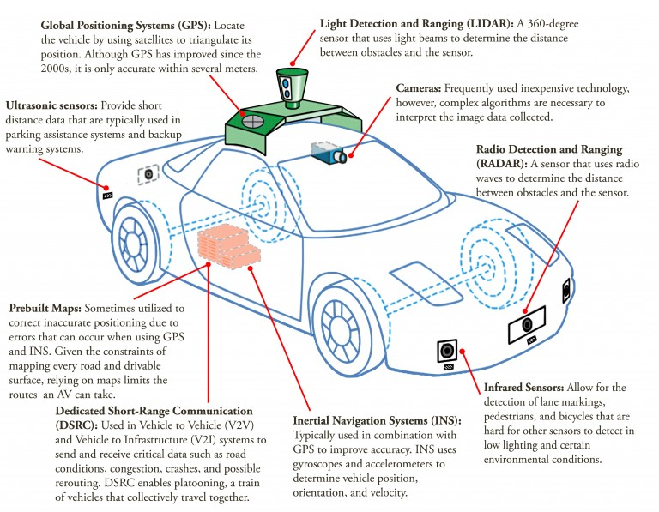

**Fig 2.1:** Properties of Autonomous Vehicle

## 2.10 IMPACTS, SOLUTIONS, AND SUSTAINABILITY

Although AVs alone are unlikely to have significant direct impacts on energy consumption and GHG emissions, when AVs are effectively paired with other technologies and new transportation models, significant indirect and synergistic effects on economics, the environment, and society are possible.19,20 One study found that when eco-driving, platooning, intersection connectivity and faster highway speeds are considered as direct effects of connected and automated vehicles, energy use and GHG emissions can be reduced by 9%.

### 2.11 METRICS AND ASSOCIATED IMPACTS

* **Congestion**: Congestion is predicted to decrease, reducing fuel consumption by 0%-4%. However, decreased congestion is likely to lead to increased vehicle-miles traveled (VMT), limiting the fuel consumption benefit.
* **Eco-Driving**: Eco-Driving, practices that typically reduce fuel consumption, is predicted to reduce energy consumption by up to 20%. However, if AV algorithms do not prioritize efficiency, fuel efficiency may actually decrease.
* **Platooning**: Platooning, a train of detached vehicles that collectively travel closely together, is expected to reduce energy consumption between 3%-25% depending on the number of vehicles, their separation, and vehicle characteristics.
* **De-emphasized Performance**: Vehicle performance, such as fast acceleration, is likely to become de-emphasized when comfort and productivity become travel priorities, potentially leading to a 5%-23% reduction in fuel consumption.
* **Improved Crash Avoidance**: Due to the increased safety features of AVs, crashes are less likely to occur, allowing for the reduction of vehicle weight and size, decreasing fuel consumption between 5%-23%.
* **Vehicle Right-Sizing**: The ability to match the utility of a vehicle to a given need. Vehicle right-sizing has the potential to decrease energy consumption between 21%-45%, though the full benefits are only likely when paired with a ride-sharing on-demand model.
* **Higher Highway Speeds**: Increased highway speeds are likely due to improved safety, increasing fuel consumption by 7%-30%.
* **Travel Cost Reduction**: AVs are predicted to reduce the cost of traveling due to decreased insurance cost and cost of time due to improvements in productivity and driving comfort. These benefits could result in increased travel potentially increasing energy consumption by 4% to 60%.
* **New User Groups**: AVs are likely to increase VMT, especially for elderly and disabled users. Fuel consumption is anticipated to increase between 2%-10% from new user groups.
* **Changed Mobility Services**: Ride-sharing on-demand business models are likely to utilize AVs due to the significant reduction of labor costs.The adoption of a ride-sharing model is estimated to reduce energy consumption by 0%-20%.
* Although an accurate assessment of these interconnected impacts cannot currently be made, several scenarios have been projected. One study evaluated the potential impacts of four scenarios, each with unknown likelihoods. The most optimistic scenario projected a 40% decrease in total road transport energy and the most pessimistic scenario projected a 105% increase in total road transport energy.

**2.12 Summary**

In this chapter the theoretical and technological alignment for the Level – 6 autonomous vehicle is described. The following chapter contains the implementation and testing the system in the simulated environment.

Chapter 3

**System Analysis**

**3.1 Introduction**

The System analysis considers the functional requirements of the project. Because of the project is not only about building a simulation but also designing, demonstrating and projecting the infrastructure, Parallel analysis is needed for both of the context. In this chapter the analysis for the infrastructure is described first and for the visualization next.

**3.2 Existing Infrastructures Near to The full Autonomy and The Advantages**

**3.2.1 Waymo**

Of course Google was the pioneer to the implementation of the self driving car. Using Google’s enriched datasets Waymo is originated. It is a wholly owned subsidiary of [Alphabet Inc.](https://en.wikipedia.org/wiki/Alphabet_Inc.) Waymo officials said the cars the company uses are built for full autonomy with sensors that give 360 degree views and lasers that detect objects up to 300 meters away. Short-range lasers detect and focus on objects near the vehicle, while radar is used to see around vehicles and track objects in motion.  
Waymo engineers have also created a program called Carcraft, a virtual world where Waymo can simulate driving conditions. With Carcraft, 25,000 virtual self-driving cars navigate through models of Austin, Texas, [Mountain View, California](https://en.wikipedia.org/wiki/Mountain_View,_California), Phoenix, Arizona, and other cities. As of 2018, Waymo has driven more than 5 billion miles in the virtual world.

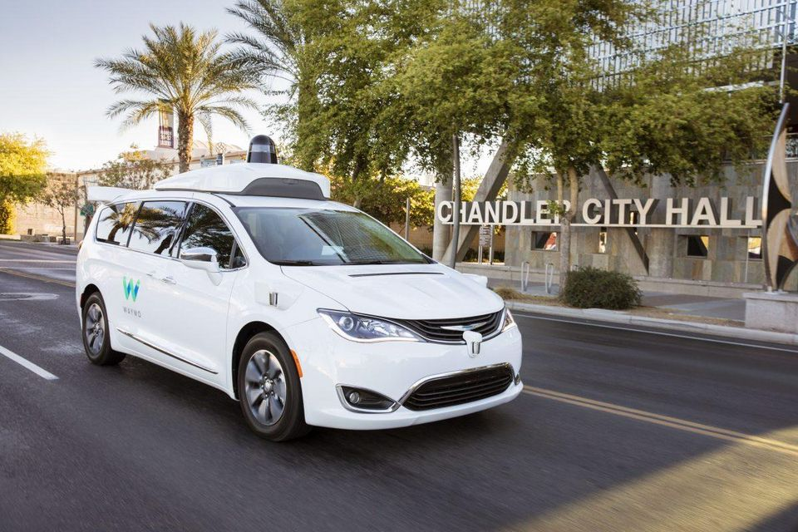

Fig 3.1: Google’s Waymo

**3.2.2 BMW’s Concept Cloud Infrastructure**

In 2019 CES BMW had showcased their Concept Cloud infrastructure for the autonomous car. According to BMW they are going to build a datacenter just to house all the data that they are getting from the cars. According to the stats one single car is going to generate 8 terabytes of data per hour to sent back to the server to analyze so that AI can learn from it.

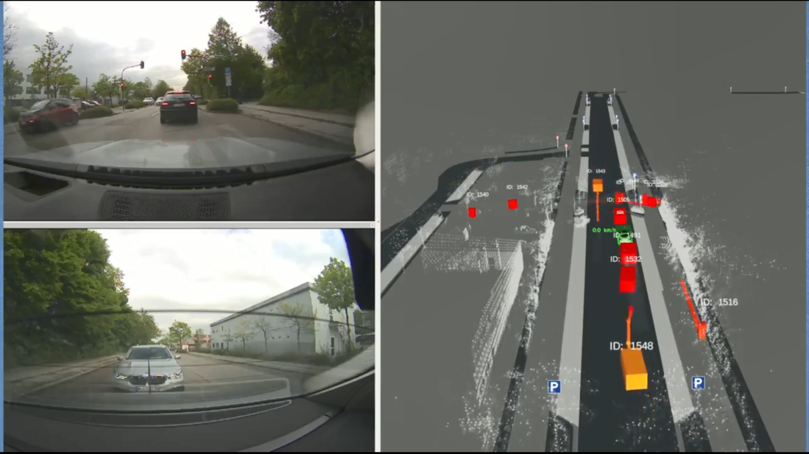

Fig 3.2: BMW’s Concept Cloud Infrastructure

**3.2.3 Samsung’s Smart City**

In CES 2020 Samsung proposed a system named smart city. According to the Samsung There will be several sensors all over the city area, Connecting by 5G technology which provides 5G connection to each vehicles and can detect traffic congestion.

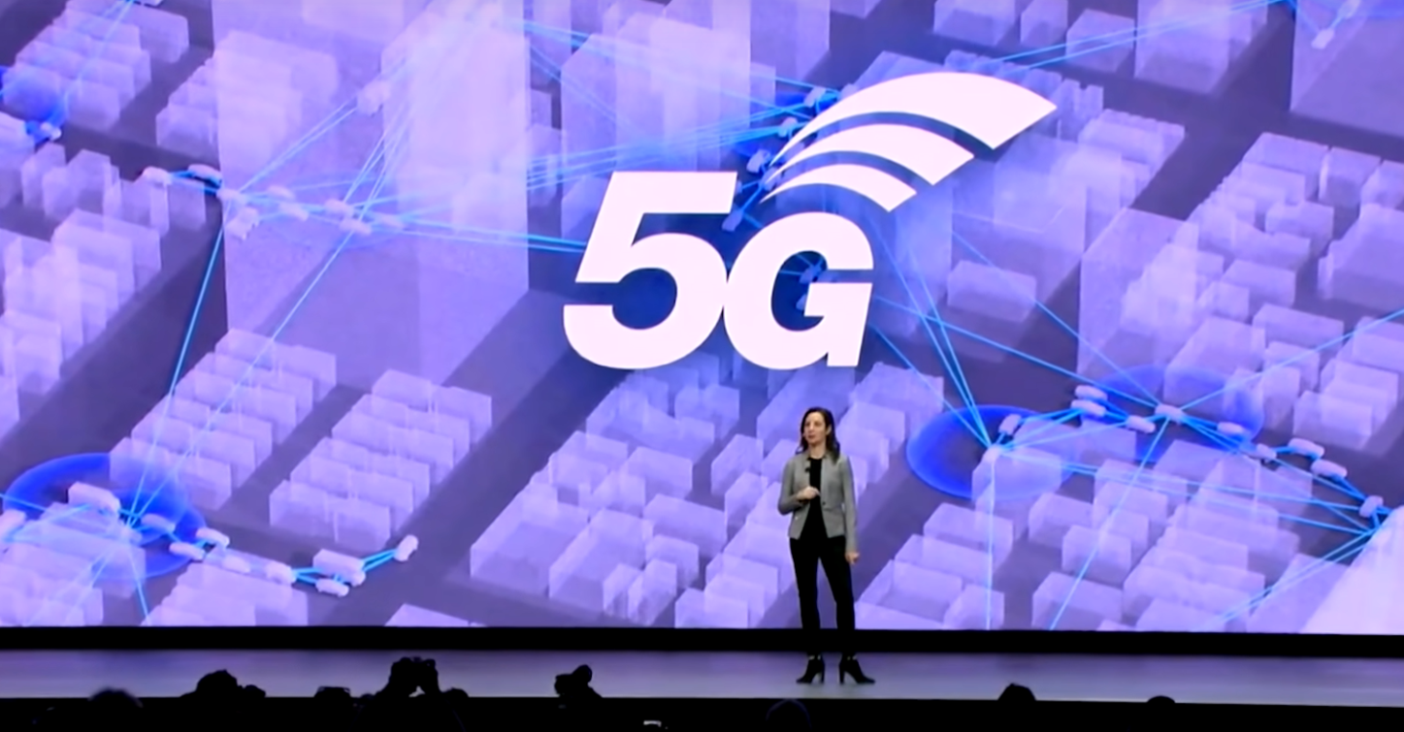

Fig 3.3: Samsung’s demonstration of the smart city

**3.2.3 Google Traffic**

Though the Google Traffic is not a infrastructure for the autonomous vehicle, It provides a good solution to control traffic congestions and this is the most used system above all.

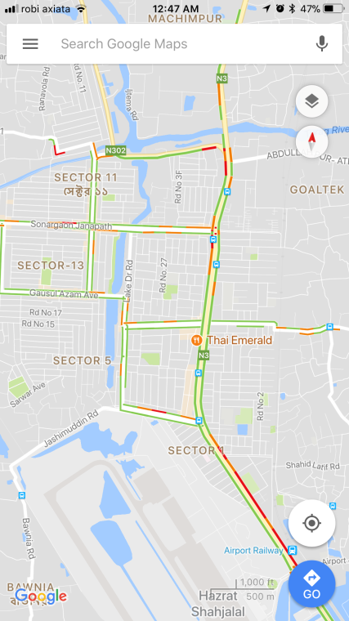

Fig 3.4: Google Traffic

**3.3 Existing Visualization System and Advantages**

**3.3.1 Deck.gl**

deck.gl is designed to make WebGL-based visualization simple. It powers many web applications at Uber that visualize large data sets with high performance.

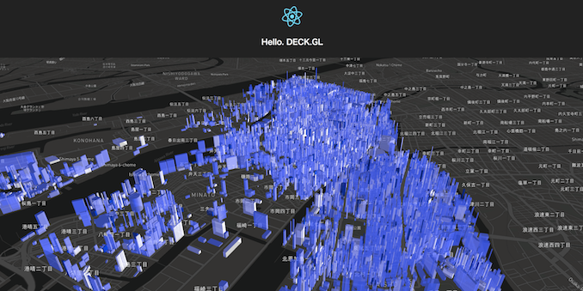

Fig 3.5: Deck.gl

**3.4 How Existing Infrastructure Works and Drawbacks.**

* Dependent on Sensors: The system like Waymo is highly based on the local car sensors. Therefore the system is functional only to some restricted area.
* Data Generator: The BMW’s concept is highly dependent on a powerful datacenter. According to the BMW’s each car generate 8 terabyte of data per hour.
* Transparency: The structures describe above has a major drawback in transparency cause none of each is transparent or open. Each system is owned by companies. The proposed system offers the transparency through the use of Hyperledger.
* Security: Just because of the lack of transparency each system fails to the chance of vulnerability. Though the companies are claiming to be invulnerable, but when a human life is involved it is not a feasible trade to technology.

Because of these drawbacks the industry is facing problem to overcome the lawsuit and take these concept to the production line.

**3.5 How Existing Visualization System Works and Drawbacks**

Most of existing visualization system is either not well functional or machine intensive. The provided reference Deck.gl is light, web based and well functional but it lacks the functionality to visualize data in real time. It works on already existing or given dataset, not capable of processing real time data.

**3.6 Summary**

In this chapter, a brief description of the system analysis is discussed. The working process and drawbacks of existing system is also demonstrated.

Chapter 4

**Proposed System Design**

**4.1 Introduction**

In this chapter we will take a look at the design an aspect of the “Traffic Symphony”. An introduction of the provided features will be given. In this chapter we will try to project the system on the simulation and the infrastructure.

**4.2 How Does The Proposed System Works?**

The proposed simulation works by projecting the theorytical infrastructure. Each Cars in the 3d simulated environment is responsive and capable of doing the functions as proposed infrastructure. Cars can detect collision, generate a signal, capable of interpreting with the virtual AI agent and can avoid collision. The local AI of the system should be able to process the generated signal and can make decision which signal should be sent to the remote server. The virtual remote AI should be able to process the generated signal and update the hyperledger and make pattern from the dataset.

**4.3 Data flow Diagram of The System**

Though the system is a simulation it should perform these tasks virtually   
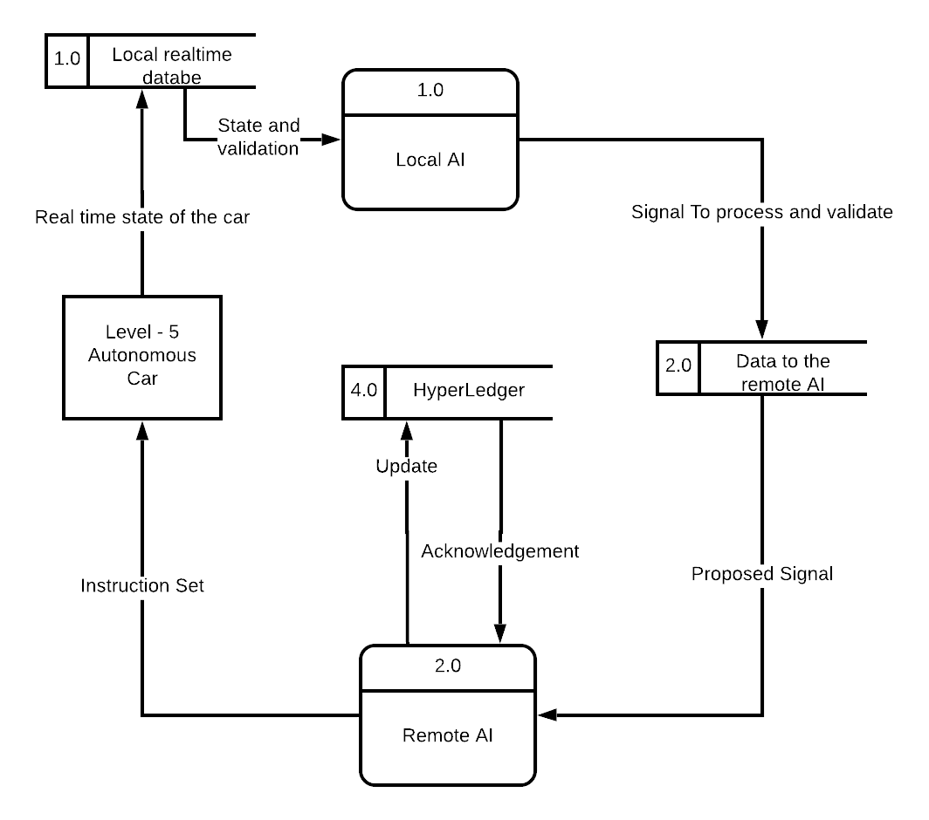

Fig 4.1 Dataflow Diagram of The infrastructure

**4.4 Requirement for The Infrastructure**

“The 6th level Autonomous Infrastructure” – Needs a whole lot of individual Infrastructure.

* 5G Network
* 6th Generation Datacenter
* Full Attorney from Government
* Mutual Agreement from Manufacturers
* New applicable Lawsuit for Autonomous Vehicles

**4.5 System Requirement for The Simulation**

“The Traffic Symphony” – The Simulation is built on web technology. Rather than using technology like Unity3d, UnrealEngine, this simulation is made by using webGL, and javascript libraries like three.js, p5.js, node.js. Using Python API for real time data handling and multithreading feature, the whole process got less processor intensive and faster. Because of using of the Rest approach the simulation puts less tasks on the host server. So many users can use the simulation.

The main context here is, Any system that can run a browser, Can run the simulation.

4.5 Summary

In this chapter, a small overview and knowledge about the approach of the proposed infrastructure and the simulation is given. A representation of the dataflow diagram is also given.

**References**

[1] Kazi Abdul Ahad, Ditee Yasmeen and Runa Rukshana Khan, **Real Time Traffic Congestion Analyzer of Dhaka City,** IST Journal on Business & Technology. Vol. 8(1), June 17: ISSN : 2070-4135

[2] Alexey Dosovitskiy , German Ros, Felipe Codevilla, Antonio Lopez and Vladlen Koltun (2017), **CARLA: An Open Urban Driving Simulator**. Intel Labs Toyota Research Institute 3Computer Vision Center, Barcelona

[3] A. Best, S. Narang, D. Barber, and D. Manocha. **AutonoVi: Autonomous vehicle planning with dynamic maneuvers and traffic constraints.** In Intelligent Robots and Systems (IROS), 2017.